Exercise: Introduction to Databases

1. Create Database

Answer: create database mydb1;

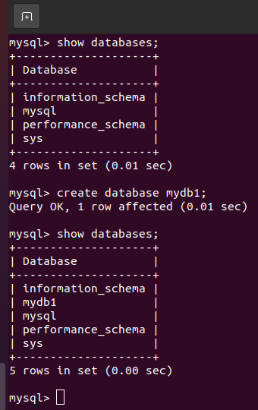

1. Design Schema

Answer: create table table1 (id int, name varchar(20));

Describe mydb1.table1;

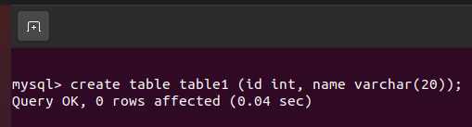

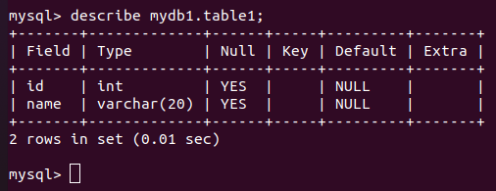

1. Create tables

Answer: create table table1 (id int, name varchar(20));



1. Insert sample data

Answer: insert into table1 values (1, “abc”);

insert into table1 values (2, “abcd”);

insert into table1 values (3, “def”);

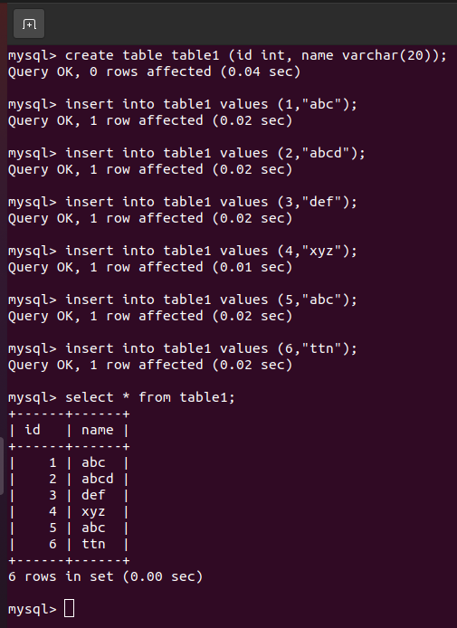

1. Find the sales person have multiple orders.

Answer:

1. Find the all sales person details along with order details

Answer: select \* from orders o join salesPerson s on s.id=o.spid;

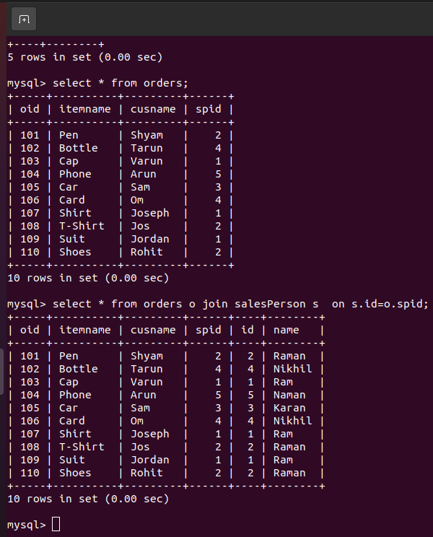

1. Create index

Answer: alter table table1 add index (id);

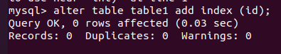

1. How to show index on a table

Answer: show indexes from table1;

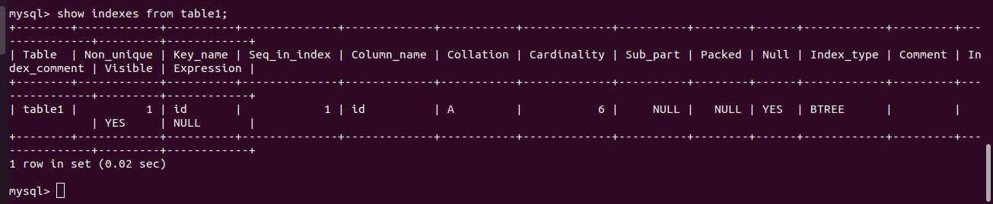

1. Find the order number, sale person name, along with the customer to whom that order belongs to

Answer: select oid, name, cusname from orders o join salesPerson s on s.id=o.spid;

